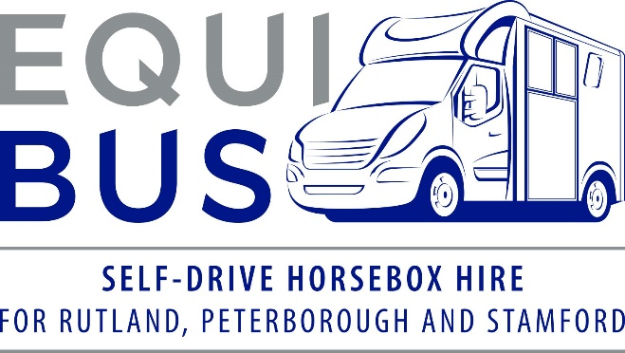

**Hirer/Driver Information and Contract**

***A form must be completed by each hirer/driver***

|  |  |
| --- | --- |
| Hirer’s name |  |
| Hirer’s home address |  |
| How long have you lived at this address? | Years Months |
| Date of birth |  |
| Nationality |  |
| Occupation |  |
| Contact details | Mobile No. |
| Home No. |
| Email address |

**Journey Details**

|  |  |
| --- | --- |
| Date/s of hire | Collection location – please circle or delete as appropriate   * Manor Farm, LE15 7DH * Wittering Grange, PE8 6NR |
| Collection date |
| Return date |
| Preferred collection time |  |
| Return time |  |
| Journey purpose |  |
| Intended destination |  |
| Estimated total mileage *(including collection and return of horsebox)* |  |
| Number of horses to travel |  |
| Estimated weight of horse/s |  |
| If having the EquiBus overnight, where will it be parked? |  |
| Has your horse travelled before, or is it a tricky traveller? (might help determine which horsebox is most suitable). |  |
| Do you have a preference for the Blue Bus or Grey Bus? Please state which one and why if so.  Please leave blank if no preference. Please visit: <https://www.equibus.co.uk/meet-the-fleet> if you need further information. |  |

* Please note, we generally allocate the horseboxes on a first come, first served basis. If you have a specific need for one of our horsebox models in particular, we will always do our best to accommodate and will always advise prior to hire if we are unable to offer your preferred horsebox on that date.

**Hirer/Driver License Information and Driving History**

|  |  |
| --- | --- |
| Country of issue of licence |  |
| Driving licence number |  |
| Date driving test passed |  |
| Driving licence categories held |  |
| How often do you drive? |  |
| Have you driven a 3.5t horsebox before? |  |
| Has your licence been suspended for any period in the last 3 years? |  |
| Have you been involved in more than one fault accident in the last 3 years? |  |
| Have you ever had motor insurance refused or declined? |  |
| Have you ever had motor insurance cancelled? |  |
| Has any insurer ever applied special terms to your motor insurance as a result of claims? |  |
| Have you had any non-motoring convictions? |  |
| Your DVLA access code | Code: |
| Valid from: |
| *The DVLA records motoring convictions electronically. We are required by our insurance provider to verify your licence details. In order to access this information, we require a one-time DVLA access code. To obtain the access code, please phone the DVLA on 0300 083 0013, or log in to the DVLA’s View Driving Licence Service on www.gov.ukcheck-driving-information (you will need your driving licence number and National Insurance No.)* | |

**Motoring Convictions**

|  |  |
| --- | --- |
| Do you have more than two convictions on your licence? | Y / N |
| Do you have more than 6 penalty points on your licence? | Y / N |
| Details of convictions in last 5 years  *Please provide details for all convictions in this period* | Date of offence |
|  | Date of conviction |
|  | Conviction code |
|  | Number of points |
|  | Fine value  £ |
| Details of any motor vehicle claims, accidents, vehicle fires and thefts in last 3 years |  |
| Please confirm if you have any BA, DD or UT convictions | Y / N  Details: |

**Medical Conditions**

|  |  |
| --- | --- |
| Do you suffer from any of the medical conditions notifiable to the DVLA? | Y / N |
| As a result of these medical conditions, have any driving licence restrictions been placed on your licence? | Please detail… |

|  |  |
| --- | --- |
| Please use this space for any other information you would like to declare? |  |

**DECLARATION**

I declare that I have read and understood the above questions and have answered accurately and in full. I agree that the information supplied may be used to check my identity and my suitability to drive and may be shared with others to facilitate the arranging of insurance on my behalf and for the purposes and processing of insurance claims.

I further agree to be bound by the terms and conditions of hire, which I have seen and read or have had the opportunity to see and read.

I hereby confirm my understanding and agreement that I am liable for the insurance excess of £500.00 in the event that the vehicle is damaged whilst in my care. The insurance excess is £750.00 where drivers are aged 23-24.

I understand that subject to the provisions of the Data Protection Act 2018, I am entitled, on the payment of a small fee, to receive a copy of the information held about me.

Hirer/Driver's Signature ……………………………………………………………………………………………………..

Date of Signing ………………………………………………